NAAN MUDHALVAN

Course: Graphic Designing with Canva

1. **Introduction:**

* 1. Overview

The "Crafting Visually Striking Certificates for a Debate Competition using Canva" project focuses on creating impressive and memorable certificates to recognize the participants, winners, and contributors of a debate competition. A well-designed certificate not only serves as a token of achievement but also reinforces the prestige and professionalism of the event.

* 1. Purpose

* Create professional-looking
* Save time and resources
* Enhance branding
* Collaborate and share designs
* Designs available for various platforms

overall, it serves as a versatile design tool for individuals and organizations.

1. **Problem Definition and Design Thinking**

* 1. Empathy Map

The map is designed about content what should reflects in a certificate

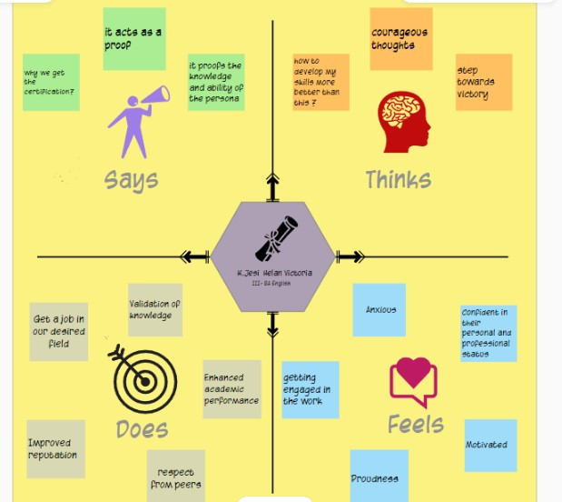

* 1. Ideation and Brainstorming Map

The map is about “Designing a certificate”

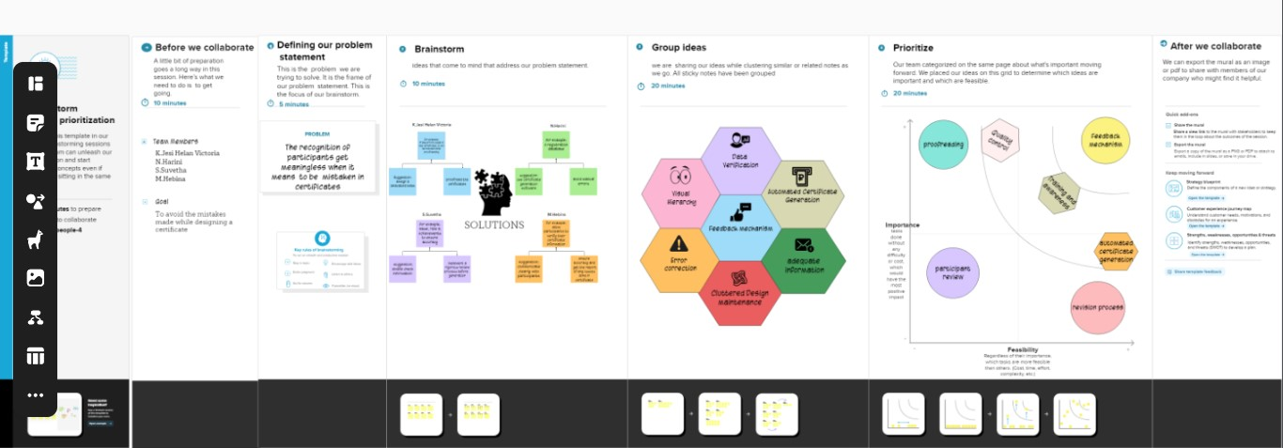

1. **Result**

Designing visually appealing certificate for debate competition

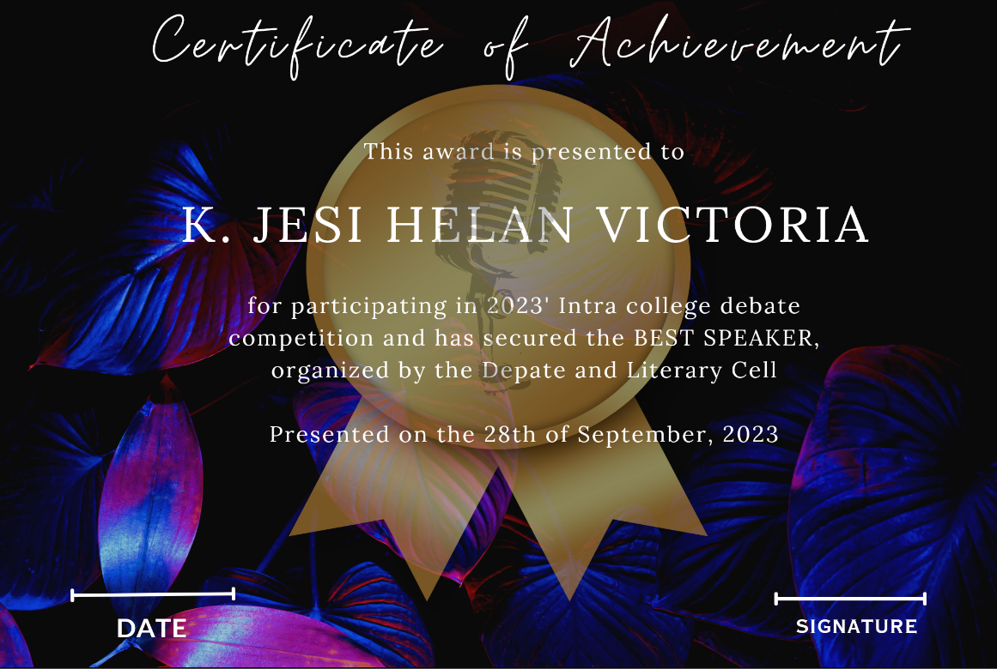

1. **Advantages and Disadvantages**

Advantages: Customization, Efficiency, Consistency,

Accessibility, Security

Disadvantages: Cost, Learning curve, Compatibility,

privacy and security, Over customization

1. **Applications**

Certainly, it can provide information on areas – specific details about field or industry and type of certificates referring to. Here, we designed visually appealing certificate for debate competition.

1. **Conclusion**

We designed certificate for a debate competition includes several key steps:

* Purpose and information- gather information such us event details, date, venue, and any specific achievements to be recognized
* Design concept- decided the theme of debate competition
* Layout and dimensions: 8.5x11 inches 0r A4
* Proofreading: double- checked the text for accuracy and spelling

Skills learned- Aesthetic sensibility, Project management, Creativity, Typography